Deploy war file using Jenkins and Ansible playbook

“Galaxy project 4 youtube”

Using plugin Over SSH

Step1: <http://103.219.61.123:7990/scm/mcto/mcto-erp-springboot.git>

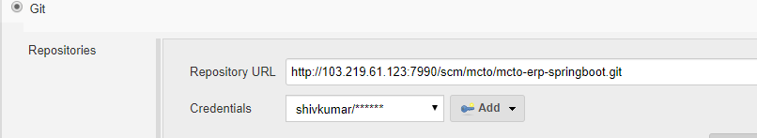

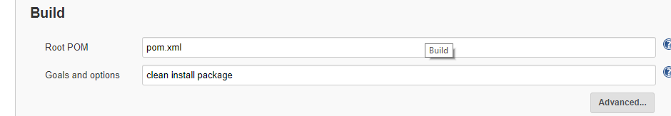

Step2: Post Steps: Send files or execute command over ssh (Ansible Server name)

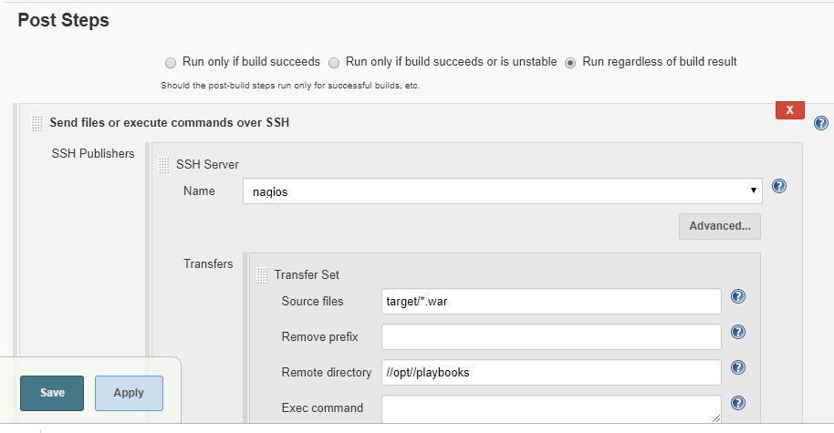

Second – over ssh

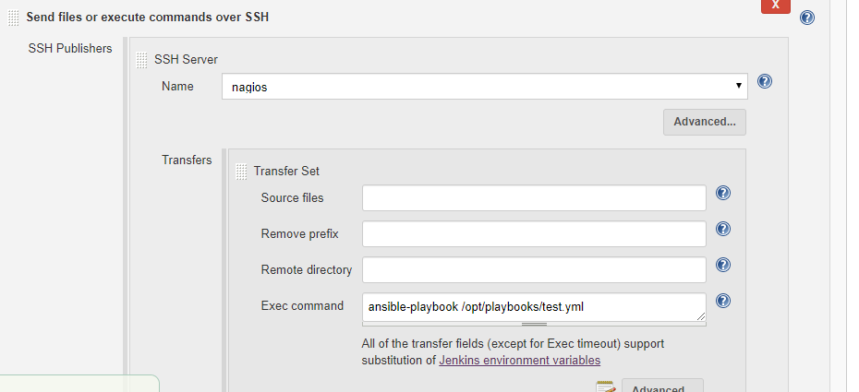

Ansible server playbook address (test149.siqes.com or nagios.siqes.com Ansible server)

Here hosts file address I have given /opt/playbook/hosts here I kept hosts file or we can create it

